Master Functional Document

Application | NGERP - Centra
Service Bundle | Master Management
Service Request | Lot

Description :

Lot Master is used to view the created lots in material receipt. User can able to view the created and expiry date for the lot in Attribute Set Instance Master.

Workflow Process :

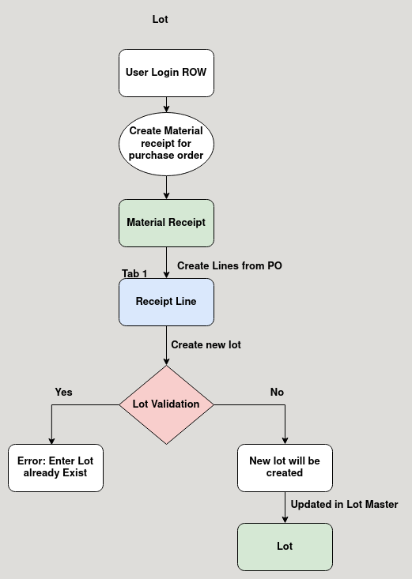

Business Rules :

- User Login Region to create lot in material receipt.
- Lot is a storage area inside locator to store products.
- User can create new lot or choose existing one to store the purchased product.
- Every lot name should be unique.
- User cannot create a new lot if there is already an existing one.
- The expirey date of the lot should be given when creating a new lot.
- The expiry date of the product is the expiry date of the lot.

